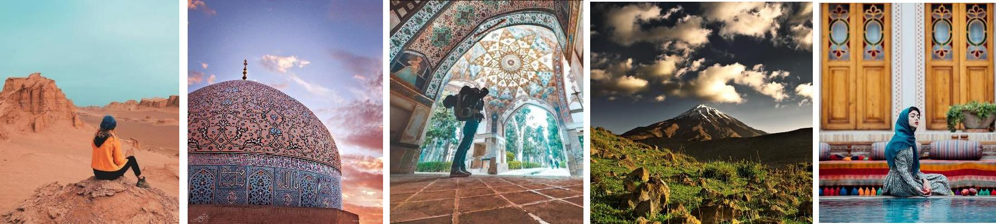

**East, south east and South of Iran**

**With**

**Cyrus Sahra Co.**

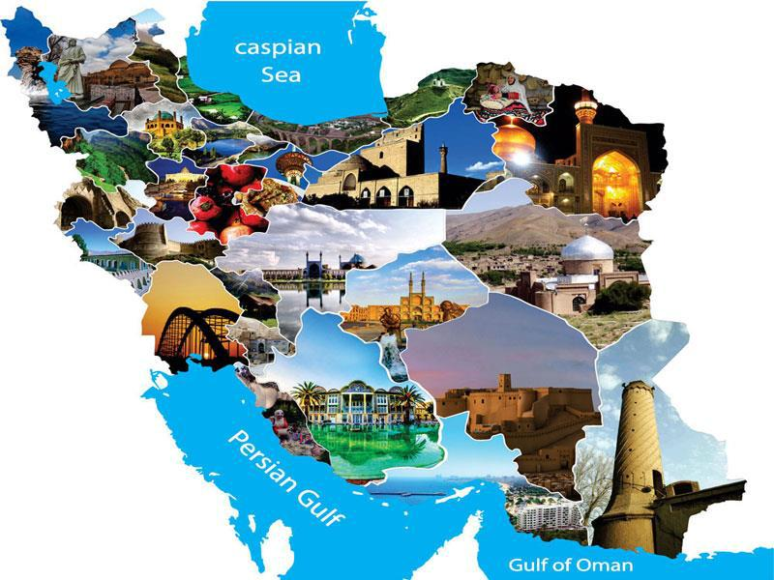

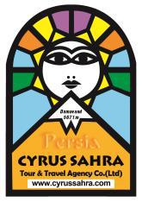

**About Cyrus Sahra**

Cyrus Sahra Co. (Ex. Caravan Sahra Co.) is one of the pioneers' incoming tour operator in Iran, doing business since 1990.

We offer a comprehensive wide range of programs throughout Iran to cover all aspects of the beauties & attractions of this wonderful country, such as: Archaeological, cultural historical, adventure, discovery, incentives, tailor made itineraries, outdoor, bird watching, botanical wild flowers, butterfly, camping, desert, nomads, horse riding, camper tours, walking, trekking, climbing, expedition, s, wild life, garden tours, skiing & skiing off the rails . . . .

Our reputation is developed on providing quality service with real personal touches.



**Treasure of Ancient Persia**

|  |  |
| --- | --- |
| Days 19 | **Trip Duration** |
|  |  |
| Cultural Tour | **Grade** |
|  |  |
| Walking and light trekking tour | **Activities** |
|  |  |
| 19 days trip, 18 nights staying in 3*,4* & 5* hotels | **Summary** |

**At a glance**

|  |  |  |
| --- | --- | --- |
| **Arrive in Mashad** |  | Day 1 |
| In Mashad |  | Day 2 |
| Mashad to Bidokht |  | Day 3 |
| Bidokht to Birjand |  | Day 4 |
| Birjand - Deh Salm - Shafie Abad |  | Day 5 |
| Shafie Abad - Keshit - Rayen |  | Day 6 |
| Rayen- Mahan - Kerman |  | Day 7 |
| Kerman - Meymand |  | Day 8 |
| Meymand - Bam |  | Day 9 |
| Bam - Jiroft - Iranshahr |  | Day 10 |
| Iranshahr - Chabahar |  | Day 11 |
| Chabahar ( Bris - Pasabandar - Guater ) |  | Day 12 |
| Chabahar - Tis - Tang Port |  | Day 13 |
| Tang Port - Jask - Minab |  | Day 14 |
| Minab - Bandar Abbas - Hurmoz |  | Day 15 |
| Hurmoz - Qeshm |  | Day 16 |
| In Qeshm |  | Day 17 |
| Qeshm - Tehran |  | Day 18 |
| Depart |  | Day 19 |

**Detailed itinerary**

Day 1



**Overnight:** Mashad

|  |  |  |  |
| --- | --- | --- | --- |
| **Arrival in Mashhad** | **:** | Hotel |  |
|  |  |
| **Arrive in Mashad at…. By….. .** | **:** | BB |  |
| You will be met and greeted by our representative and transferred to your hotel in |  |  |  |
| Tehran. |  |  |  |

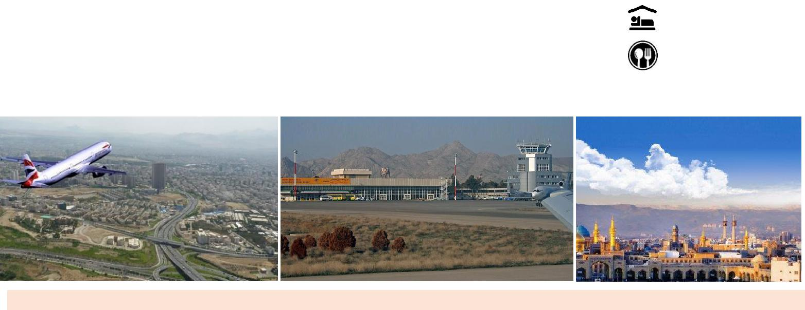

Day 2

**Overnight:** Mashad

**In Mashhad**

**:** Hotel

Today we explore Mashhad and its surroundings. Revered as the final resting place BB

of Imam Reza, this morning we will visit the spectacular **shrine of the eighth Shia**



**Imam**, one of the largest mosques in the world. Set within the confines of a walledenclosure in the heart of the city, the site is filled with a wonderful array of mosques, courtyards and madrasahs and, whilst the shrine itself is off-limits to non-Muslims, the complex presents a fascinating place to explore. You will also visit the

**Quranic Museum** and **Ferdowsi tomb**.

In the afternoon go to the countryside "**Torghabeh**" and at leisure!

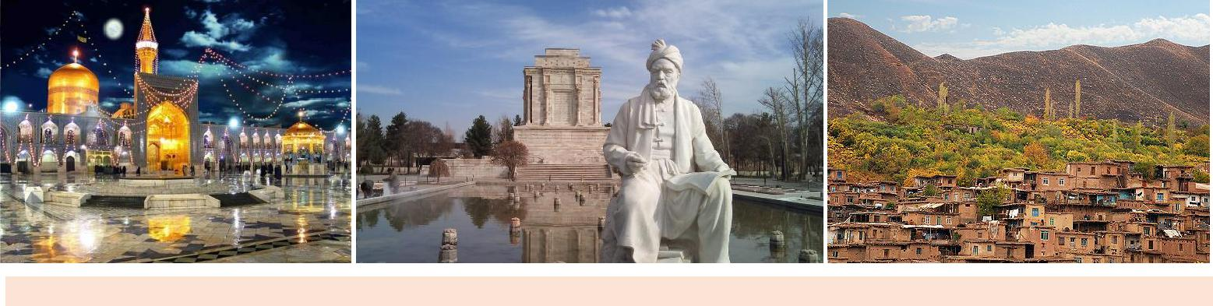

Day 3

**Overnight:** Bidokht

**Mashhad - Bidokht**

**:** Hotel

Departing Mashhad we head south this morning, towards the town of Bidokht. ON BB

arrival we will have a chance to visit the ancient **Qanat (irrigation system)** at nearby



Gonabad. One of the oldest and largest of Persia's famed aquifers, it stretches for



some 33 kilometres and contains 427 individual wells, the deepest of which drops down over 300 metres. Close by is the traditional mud-brick **village of Rihab** and, after checking in to our hotel, we plan to visit the **old abandoned part of town** and its nearby ice house.

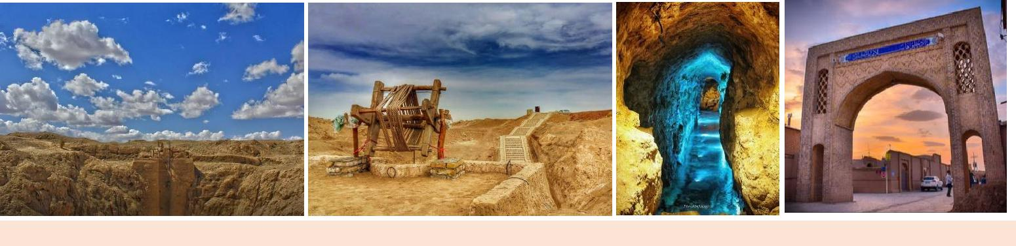

Day 4

**Bidokht - Birjand**

Continuing on through the low hills of Khorasan Province today, we head for the once strategic town of Birjand, situated midway between Mashhad and the Pakistan and Afghan borders. The journey takes us via **Ghaenat** and **Ariyanshahr** and there will be opportunities to visit some of the region's famous gardens and museums today, including the **Rahim Abad Gardens** and the **archaeological and** **anthropology museums** which are housed in the atmospheric setting of one ofBirjand's old mansion houses. Other stops today include the ruins of **the Kolah** **Farangi citadel** and the town's covered bazaar, which provides an interesting spotto try out your bargaining skills.

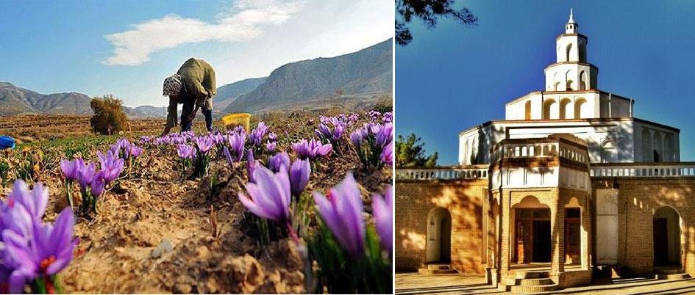

Day 5



**Birjand - Deh Salm - Shafiabad**

Today's journey takes us through **Sarbisheh** and **Nahbandan** and on towards **Deh** **Salm**, with its numerous camels. Then it is on through the surreal landscapes of the

Lut Desert, considered to be the world's hottest. A dramatic landscape of towering sand dunes and sculpted rock formations, this is a land devoid of life, but filled with adventure. On this long but fascinating day's drive, we will pass **the windmills** at Nahbandan and can enjoy a refreshing dip in the **qanat pools** at Deh Salm, before

**Overnight:** Birjand

 **:** Hotel

 **:** BB

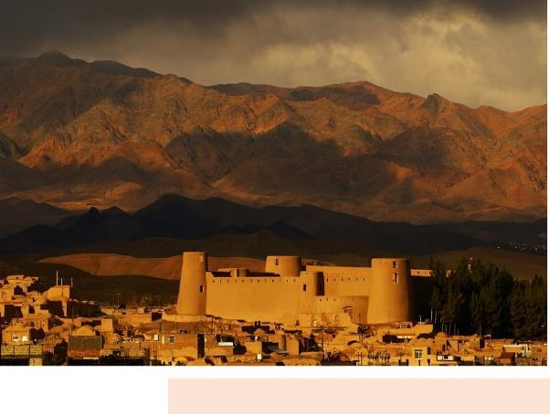

**Overnight:** Shafieabad

 **:** Local house

 **:** HB



crossing the River Shour to arrive amongst the eroded mesas of the **kaluts** in time for sunset. From here it is then just a short drive on to our night stop in Shafiabad.

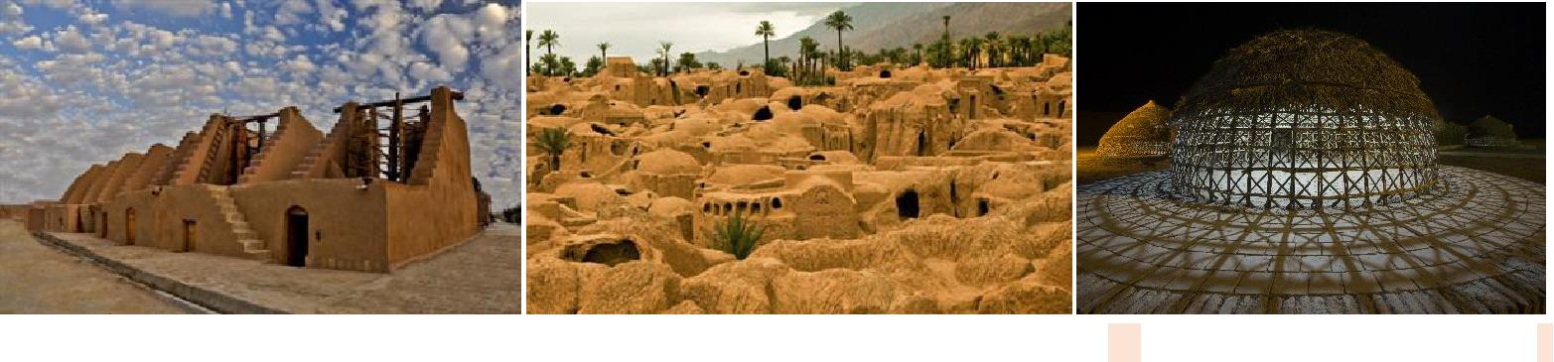

Day 6



**Overnight:** Rayen

**Shafiabad - Keshit Village - Rayen**

**:** Hotel

After visiting **Shafiabad s fort** this morning, today's journey takes us out of the **:** BB desert and through the mountains towards the **oasis village of Keshit**. The village



lies at the southern edge of the Lut Desert and is home to a number of traditional houses and an old fortress that dates back to the Seljuk period. Our pleasant drive takes us through **Godiz and the Andouhjerd Valley** and past the saw-shaped **Jahr** **Hills towards Kahnouj**. After exploring Keshit we will continue on to **Rayen** tospend the night.

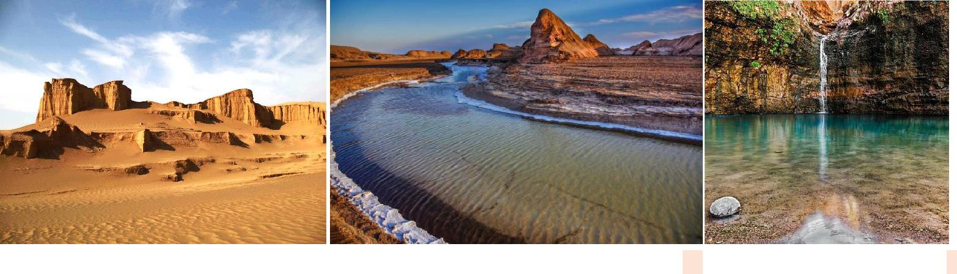

Day 7



**Overnight:** Kerman

**Rayen - Mahan - Kerman**

**:** Hotel

This morning first we visit visit **1000-year-old castle of Rayen** drive on to Mahan **:** BB

and Enjoy a full day excursion to Mahan, a lovely oasis village, home to the



Mausoleum of Shah Nematollah Valli, founder of the Soufi order.

Take a walk in the cool **Shahzadeh UNESCO registered garden** with its collection of pools, against their backdrop of snow-capped mountains. You can also visit **Shah** **Nimatullah Vali Mausoleum complex**, which includes several courtyards and amosque, and is the tomb of a 15th century Sufi master, mystic and poet that attracts countless visitors every year. You can also visit the **Shotor Galoo House** in Mahan which is a Qajar structure in Mahan, unique in its decorations and lavish pool house (Howz Khaneh) that appears to produce the sound of a caravan and its camels passing by when water flows through its fountain. After our visit, we head



next towards Kerman, the provincial capital and a city that has long been considered one of the most important in south-eastern Iran.

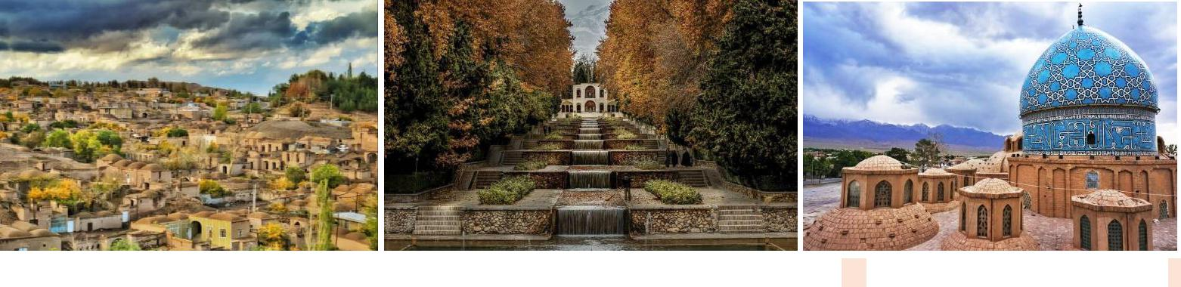

Day 8



**Overnight:** Meymand

**Kerman - Meymand**

**:** Hotel

Kerman, Famed for its long history and cultural heritage, Kerman is home to a rich **:** BB

collection of mosques and Zoroastrian fire temples. With a half day to make the



most of the city, we have the opportunity to pay a visit to the **Safavid Ganj Ali Khan** **complex**, the ١٧th century mint, the bathhouse and caravanserai. Boasting theworld's only Iranian museum solely dedicated to the **anthropology of the** **Zoroastrians**, Kerman is an ideal city to enjoy and discover at our own pace, withthe **bazaar** providing the perfect setting to look for some traditional handicrafts and souvenirs. Then continue to **Meymand, a UNESCO listed village** which dates back 12000 years and where the villagers live in hand dug houses among the rocks, some of which have been inhabited for 3000 years.

Arrive in the late afternoon giving you time to wander around the village. You will spend tonight in the village and sleep in one of the caves furnished simply with mattresses and rugs.

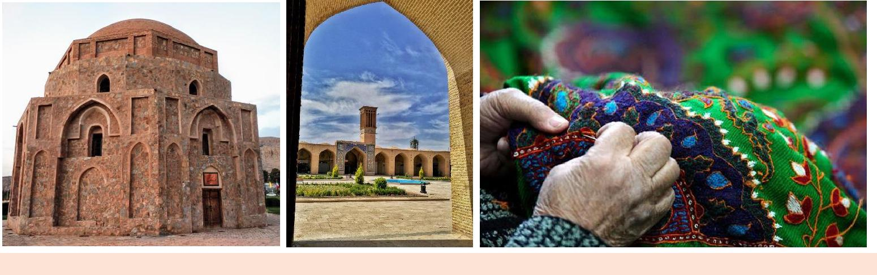

Day 9

**Overnight:** Bam

**Meymand - Bam**

**:** Hotel

This morning we drive on to the capital of Bam County, the modern city of Bam, BB

which was devastated by the earthquake that hit the city on 26 December 2003.



Estimates put the death toll at over 26000 and much of the city was levelled by the 6.6 magnitude quake. Since then, much has been done to rebuild the city and its **ancient fortress** and today we get an opportunity to discover a little of the

magnificent splendor of the ancient **citadel of Arg-é Bam** for ourselves. Dating back to the Parthian Empire, with the ruins spanning a history of over 2000 years, we arrive around lunchtime today, and will spend the afternoon exploring the city and some of its remaining treasures.

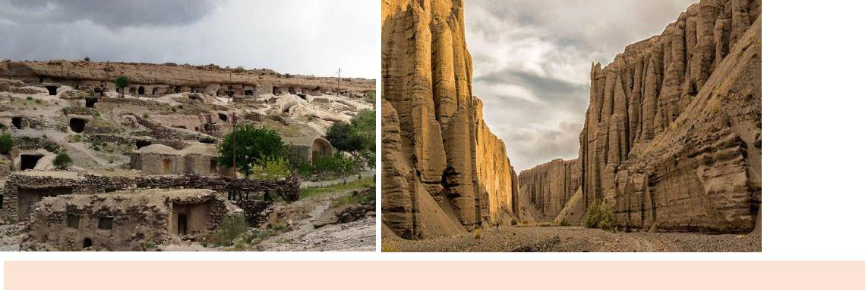

Day 10

**Bam - Jiroft - Iranshahr**

Today our Journey take us to Sistan and Baluchestan province via **Jiroft** where The Baloch are the majority ethnic inhabitants of the region. They speak Rakhshani Balochi, an Iranian language.

Approximately 25 percent of the Baloch population lives in Iran: media reports indicate there are 1.5 million Baloch in Iran. The utter vast majority of the Baloch population reside in Pakistan, and a significant number i.e. 600,000 reside in southern Afghanistan.

In Iran, the Baloch are divided into two groups: the Sarhadi and the Makorani. The cities such as Iranshahr, Chabahar, Nikshahr, Sarbaz, and Saravan are known as the Makoran region, while Zahedan and Khash are known as Sarhad region.

The government of Iran has been trying to reverse this situation by implementing new plans such as the creation of the Chabahar Free Trade Zone.

**More about Jiroft ancient civilization**

Jiroft ancient civilization is a symbol of Iranian ancient civilization. The history of the region dates back to more than 4,300 years ago. Today Jiroft is a city in Kerman province. Historical and archaeological findings in the region indicate lots of pieces of evidence of the original great civilization in the region. These works represent a part of the ancient Iranian culture and civilization.

Jiroft historic site dates to the third millennium BC. The region was once the bridge between the Ilam civilization in the west and the Sindh Valley civilization in the east

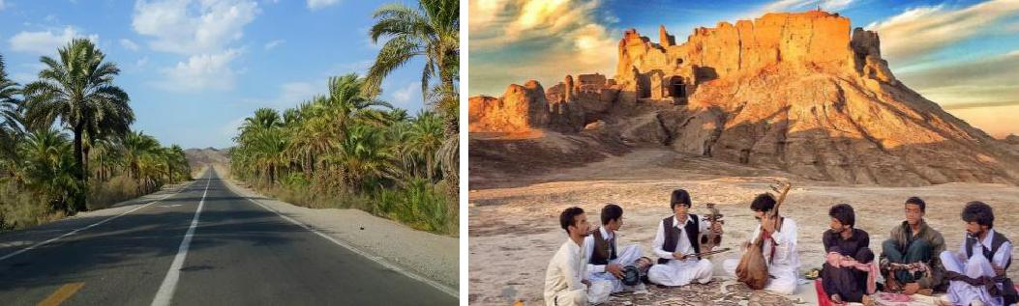

**Overnight:** Iranshahr

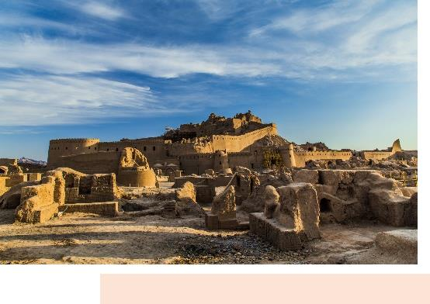

 **:** Local house

 **:** HB

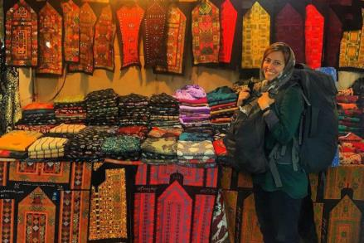

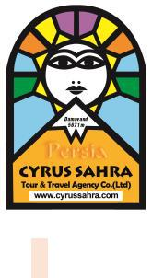

Day 11



**Overnight:** Chabahar

**Iran Shahr - Chabahar**

**:** Hotel

Leaving Iranshahr this morning toward Chabahar along the beautiful **river of**



**Sarbaz**. First move to **Bahu Kalat protected area** near **Sarbaz (soldier)** river to visit **:** BB

an extremely **rare mugger crocodile known as Gando** (An extinct species), then

explore the **Banana Gardens** and get the chance to see the Northern **palm** **squirrels**.

Around early evening we reach to Chabahar. Visit a unique climate of a city with special eco system, Get dazzled by Stunning places.

Enjoy the **Chabahar Bay sunrise** and **sunset at sea**. Take an excursion in **Bazaars**, Relax in classic teahouses and meet the friendliest locals in the world.

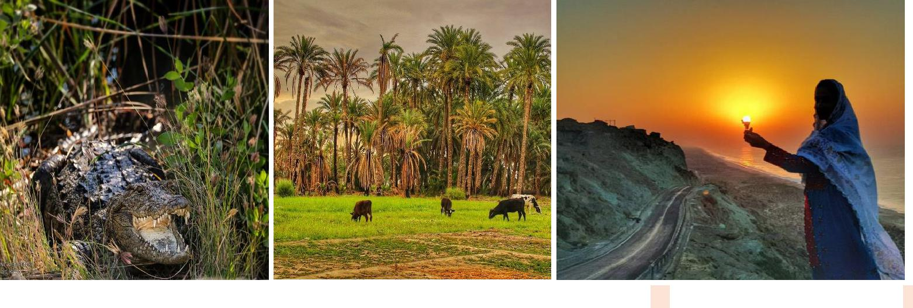

Day 12



**Overnight:** Chabahar

**Chabahar ( Bris - Pasabandar - Guater )**

**:** Hotel

Move to visit **Mars or Martian mountain** located on the route, after that go on BB

exploring **Gwater Gulf** a geomorphological phenomenon.



Then continue exploring the magnificent **rocky coast** and then enjoy observing the alluring natural attractions of the area and see a breathtaking **pink lake in Lipar** **Lagoon**.

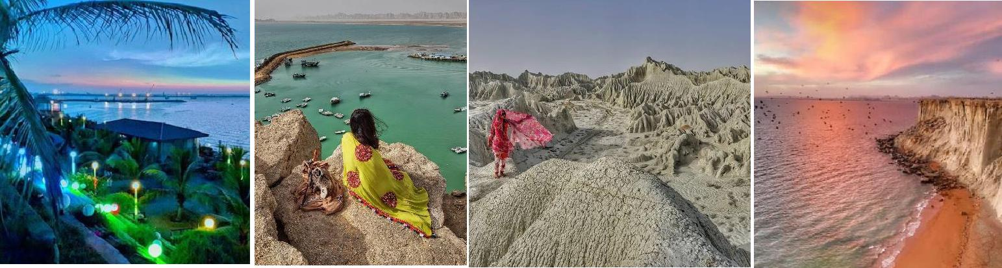

Day 13



**Chabahar - Tis - Tang Port**

Today we continue our tour to **Wave volcano phenomenon**, **Mud volcano** which is an amazing geo tourism phenomenon, **cemetery of Jinn in Tis** historical village and explore the **Botanical Garden** to see the inimitable and unique nature of the area, then spend the rest of the day exploring the historical site of **Jameh mosque.** Continue to Tang Port.

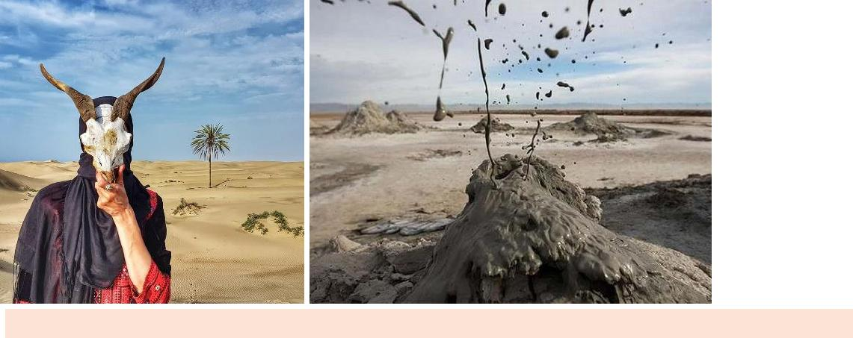

Day 14

**Tang Port - Jask - Minab**

Today we will move toward Minab via Jask.

Minab is famous for fishing (especially shrimps) and for agriculture (especially **date** **palms and mangoes**).

It lies on the main official road connecting Bandar Abbas, the Makran and the Baluchistan Province. Once a week, a well-known bazaar called "Panjshambe bazaar" (**Thursday's Bazaar**) attracts people from all over Hormozgan, and beyond. In ancient times Minab had the name of Harmosia. Here we visit **sacred Fig tree**.

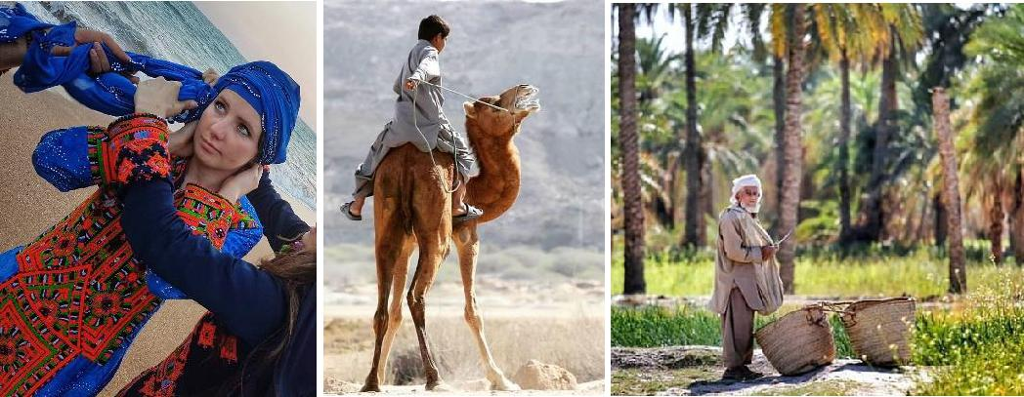

**Overnight:** Tang Port



**:** Local house



**:** HB

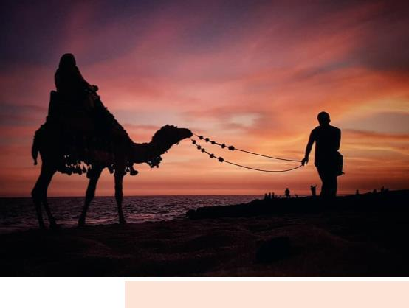

**Overnight:** Minab



**:** Hotel



**:** BB

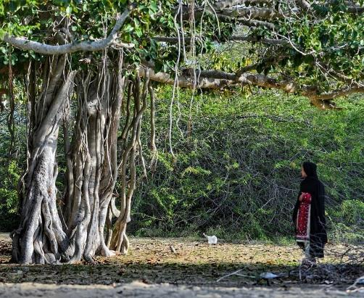

Day 15



**Minab - Bandar Abbas - Hurmoz**

After breakfast continue our journey to the most mysterious Island "**Hormuz**". **Hormuz Island** in the **Persian Gulf**, the mostly forgotten land of colors in the Straitof Hormuz, 5km from the mainland, and southeast of Bandar Abbas, major port and capital of the province of Hormuzgan.

The island was visited among others by Marco Polo. Ibn Battuta who came twice between 1330 and 1340, wrote that the island's city was "fine" and "large...with magnificent bazaars."

To get to **Hormuz**, you will need to take a ferry from **Bander Abbas** where has airport and also rail-links to much of Iran. As soon as the boat arrives and you get on land, you will be transferred to your accommodation (local house) for leaving your baggage and take a short rest).

**What to see on Hormuz Island**

There is one road around Hormuz Island and mountains and rocks in the center. The island is mostly free to explore and it greatly depends on how much time you have and what you're interested in. In one day you can easily see the main attractions' of Hormuz Island. But if you have extra time there are many local secrets to discover. **Salt mine, salt cave, colorful valley, statues valley, remains of** **medieval Portuguese castle.** Moreover you can get a ride on boats to explore some **amazing beach scenery**. Don't forget to try **local seafood**! You can decide to leavethe island at evening or stay in a local house.

As you don't have enough time to explore the Island, we just mange a ride to get around and enjoy the sunset by **eye-catching Persian Gulf**.

**Have you ever heard of the edible mountain (Hormuz Culinary)?**

The people of Hormuz have their own special way of cooking. They take the fresh fish of their waters, such as sardines, kilka and another kind called momagh', clean them and marinate them in the peel of sour oranges and this particular sauce in a large container and leave it in the sun for two days. Then it's cooked to become a delicious meal called **suragh**'. Its appetizing taste and color is very popular among tourists from both Iran and abroad. Very few visitors to this island leave without having tasted the dish. The same red soil is also used in baking the local bread called

**Tomshi**'. The same bread is cooked in neighboring islands with cheese or dabbledwith eggs; but Hormuz has its own special recipe made with suragh' which is rather popular.

The moon appears from behind a pillar of rock, illuminating the scene. There is a purple tint to the air, the sky is an electric blue punctuated with pinpricks of light, a million stars. A full moon, a perfect beach, a delicious southern Iranian cuisine and dinner sizzling away, dazzling sands… isn't it romantic?

**Overnight:** Hormuz Island

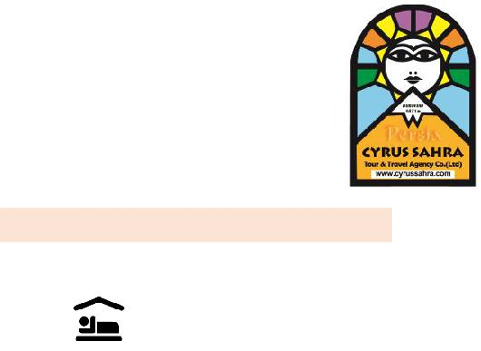

**:** local house



**:** HB

Best months to visit Hurmoz and Qeshm Islands: NOV, DEC, JAN, FEB, MAR.

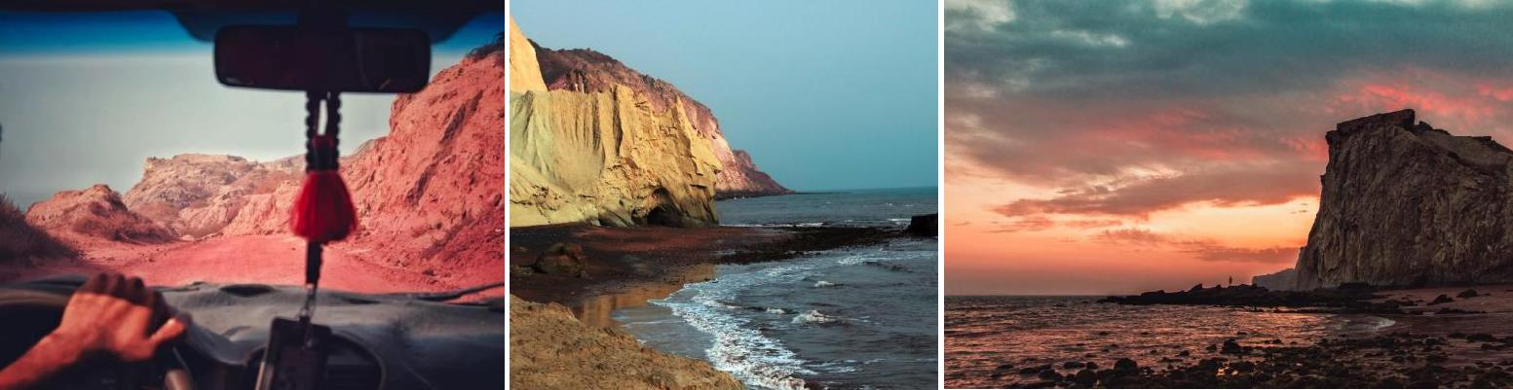

|  |  |  |  |  |
| --- | --- | --- | --- | --- |
| **Day 16** |  |  |  |  |
|  | **Overnight:** | Qeshm |  |  |
| **Hurmoz - Qeshm** | **:** | Hotel |  |  |
|  |  |  |
| **Hormuz** a magical rainbow colored gem island in the world. The town is tiny, a | **:** | BB |  |  |
| collection of simple buildings and two or three shops selling basic supplies. We |  |  |  |  |
| stock up on food and water before starting our tour; whilst the town is nice, this is |  |  |  |  |
| not why we are here. Hormuz island is a special place, this is a geological |  |  |  |  |
| wonderland… |  |  |  |  |
| Ready for the single most exhilarating drive of your life, hit the road and head out |  |  |  |  |
| into **the sun-scorched, rainbow landscapes of Hormuz**. |  |  |  |  |
| During the way you will see **mountains of red, purple, yellow and blue** explode |  |  |  |  |
| into the sky like impossible rocky mushrooms on all sides. Bands of color zig and |  |  |  |  |
| zag in impossible patterns and Psychedelic vibes….. |  |  |  |  |
| Our first spot is **Rainbow mountain** |  |  |  |  |
| You can freely walk through most of the middle of it. But this spot is a good place |  |  |  |  |
| to stop and check out all the colors. There are a few local women selling souvenirs |  |  |  |  |
| and ١٠c samosas but it's far from a bustling tourist attraction. |  |  |  |  |

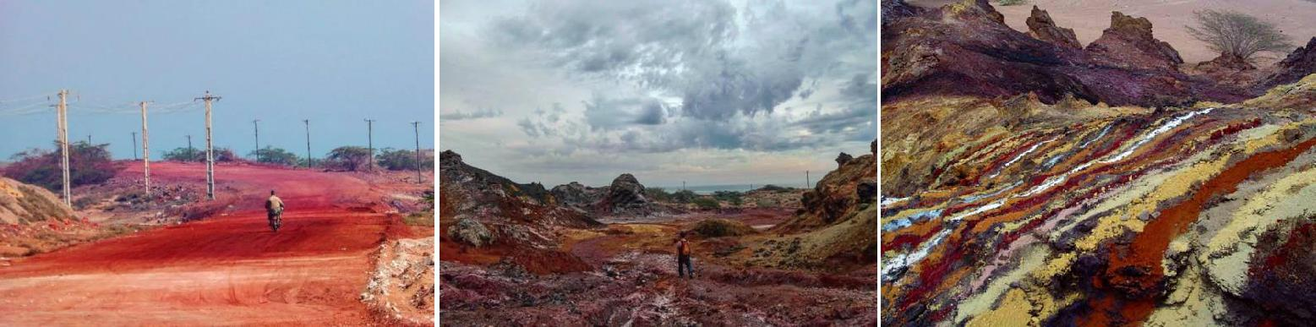

Then we continue to **Valley of the Statues**

You can spot this from the small hut on the side of the road. Walking a little further there are all kinds of rocks that have been shaped by wind, rain and age into a variety of interesting shapes.



With a few hundred meters walk to the beach, in a way that silver sands attracts attention, rocks can be seen in many different forms, each is likened to an animal, a sheep's head, poultry and many different Dragons.

The rocks show that, over thousands of years that the island of Hormuz gradually comes out of the water, the wear and tear on it makes many beautiful shapes.

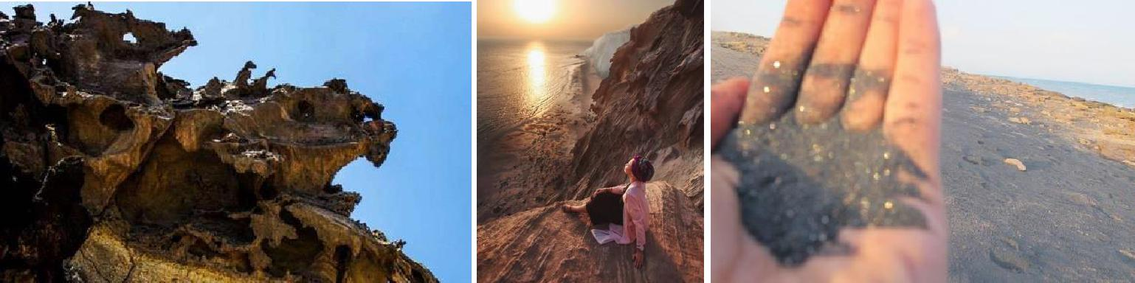

Next we take a walk on **dreamy Silver, Red beach and the hole in the Rock**

**The Silver Beach**

Patches of silver sparkle like glitter as the waves rush in that nobody cannot help himself to not dump my stuff and run to the water, wading into the cool refreshing waves of the Persian Gulf.

**The Red Beach**

The beach itself is just normal sand but the hills around are a beautiful, deep red. The water is also colored by this rock and washes a dark red onto the shore.

**The hole in the Rock**

As it says, a natural archway in the rock. The beach here is nice and peaceful as well.

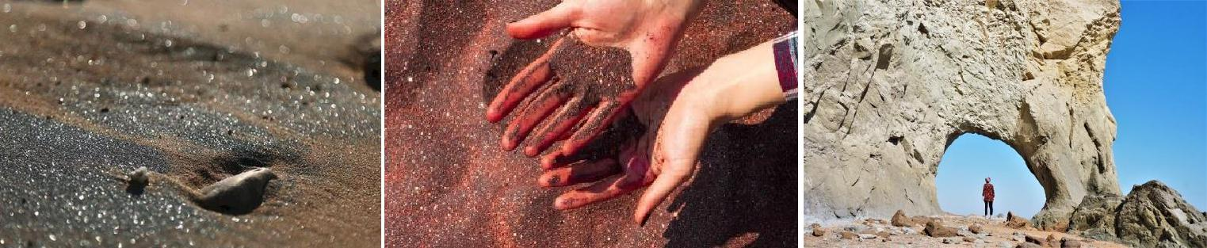

Our last spot in Hormuz Island is **Portuguese Castle**

**Portuguese Castle**, is a red stone fortress on Hormuz Island. It is one of the lastsurviving monuments of Portuguese colonial rule in the Persian Gulf.

Constructed on reddish stone on a rocky promontory at the far north of the island, the castle was originally cut off from the rest of the island by a moat, traces of which still remain.



After our visit around Hormuz, we go for Lunch in a local house and then transfer to port for leaving Hormuz to **Qeshm Island**!

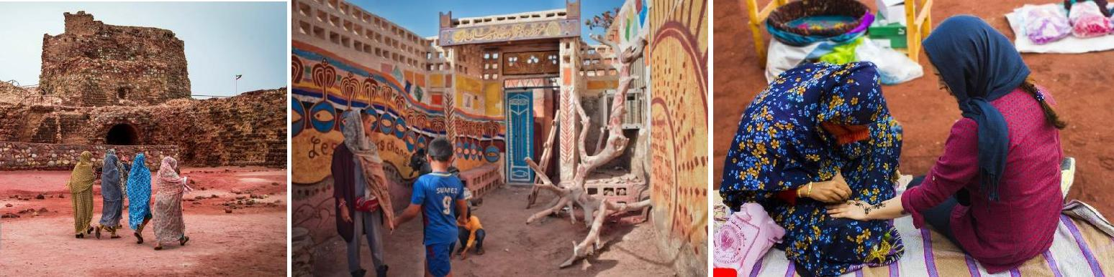

Hormuz needs to be seen to be believed.



Day 17

**Overnight:** Qeshm

**In Qeshm**

**:** Hotel



**More about Qeshm :** BB

Visiting Qeshm Island is a must for any travelers wanting to get off the beaten path

in [Iran.](https://www.lonelyplanet.com/iran) In fact it's one of the top things you can do in south of Iran.

Traditionally, homes on the islands were all built with **wind-catchers**. But today, on Qeshm, **Loft village** is the only place where they can be found. Following an earthquake in 2005, the houses were rebuilt with cement and air-conditioning. "It's an archaeological artefact," a woman tells me, pointing to her wind-catcher.

Fishing is a main source of income across the Persian Gulf islands, but one that has always been associated with a more humble lifestyle. Driving around Qeshm, the fishing villages are always more simple than where smugglers, merchants, dhow constructors or mall-owners live.

Local cuisine, especially on Qeshm, which sees most tourists, is plentiful and delicious, with seafood offered once the sun sets and residents get out by the water. Octopus, fish and shrimps are sautéed with onions, tomatoes and local spices, and put into a sandwich with pickled cucumbers and cabbage. A local mix of ten spices and herbs including turmeric, cloves, dried rose petals and cinnamon makes meals exemplary.

**ChahKouh Canyon**

It's an amazing spot in Geopark of Qeshm Island in Iran .it's like a mysterious valley, a suitable place to film Hollywood movies. You can't believe your eyes. The rounded edges and sharp corners have made a symphony in the canyon. A perfect place made by sea, wind and rain. You can seat and relax for two hours there and enjoy what you see Chah kooh Canyon in the Persian Gulf Island of Qeshm is made of Marl Sandstone which has holes created by the flow of rain water.



**Fantastic Hara Forest**

Hara Forest or the Mangrove Forest is located in beautiful Qeshm Island, Hormozgan Province, Iran. This forest is an important ecological resource and covers an area of approximately 20 km by 20 km. In Hara Protected Area the commercial use is restricted to fishing and boat trips. It is a biosphere reserve. The trees, which are salt-water plants, have three to eight meters height. The jungle is a major habitant for birds such as eagles, flamingos, pelicans, and herons; fish; reptiles; turtles; snakes, etc.

**Star Valley**

You should definitely visit it. The landscape in amazing and unique. Moreover the villages in the area are still very authentic.

The Stars Valley is one of Qeshm's wonders. There are different views about the origin of this place. Some Natives believe this place was by the jinns. However, the other people lead to believe that Star collisions with Earth led to create such a wonder. Nevertheless Geologists believe that the cause is due to erosion and heavy winds and rains. To visit the Star Valley The closest village is Berkeh Khalaf in ٥ kilometers away. Take comfort shoes and water with you as you are going for a long walk. Transfer to the hotel.

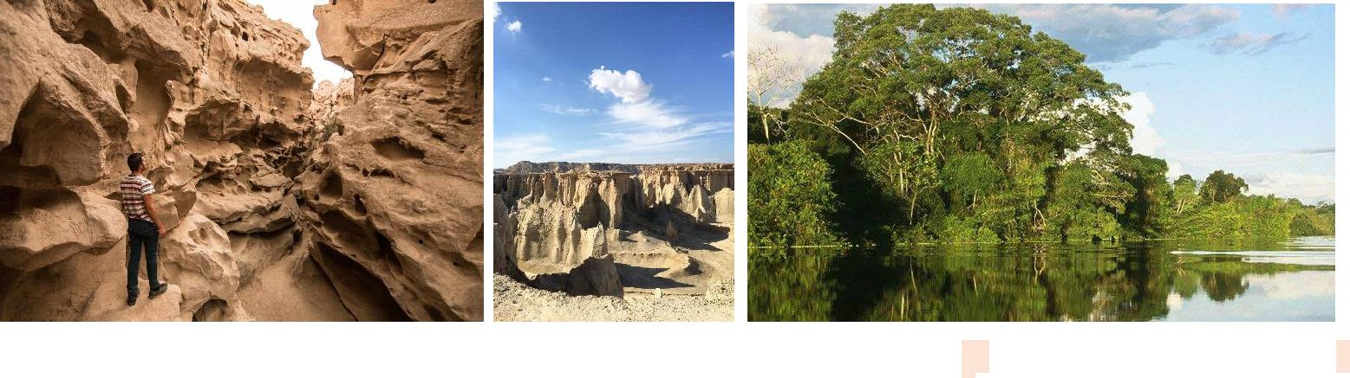

Day 18

**Overnight:** Tehran

**Fly From Qeshm to Tehran**

**:** Hotel

Visit Hengam Island and then fly to Tehran.

**:** BB

**Hengam Island**

Very inexpensive, when the sea is calm the dolphins come to the surface, beautiful, there in the island you can enjoy a kind of donut with mushrooms, must go! Hengam Island is a small island near the Qeshm Beautiful and hearty nature on the way to this Island If you're lucky you will enjoy watching free Dolphins that are amazingly play around the boats.In Hebgam island, you will find many attractions. Local market, local food, having a pleasant conversation with locals, watching the



dolphins swimming in Persian Gulf and very clean, nice and calm beaches will make one of the most memorable trips for you in Iran. For going to this island, you have to go from Qeshm to Shib Deraz village, then take a boat to the island.

Return to Qeshm airport and fly to Tehran.

Day 19



**Overnight :** ------

**Depart Iran**

**:** ------

Leave Iran for…… by…… at …….

**:** ------

Have a nice Trip!

**Included:**



* All transfers & sightseeing
* Meal: BB in Cities and HB in Local houses
* Entrance fees
* 24/7 support
* Refreshments during the trip
* Best available accommodations
* Experienced guide
* Vehicle & driver
* Via assistance